PPE: Change in Seal sample
On 30/06/2017, PetroVietnam Power Engineering Consulting Joint Stock Company announced the change in Seal sample as follows:
- Seal sample
Old seal | New seal
Broken:  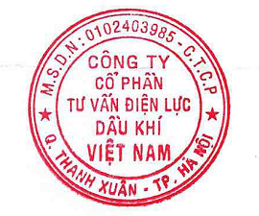 | 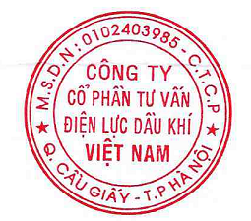
- Number of Seal
- Number of Seal before change: 01
- Number of Seal after change: 01
- Effective date: 29/06/2017

